ADITHYA R
192311369

Experiment – 16
Question:
Create a Cloning of a VM and Test it by loading the Previous Version/Cloned VM using vmware workstation.
Answer:
AIM: To clone a virtual machine using VMware Workstation.
SOFTWARE REQUIRED: VMware Workstation 17, Ubuntu ISO, Host OS: Windows
PROCEDURE:
STEP 1: Launch VMware Workstation
Click Start → VMware Workstation 17

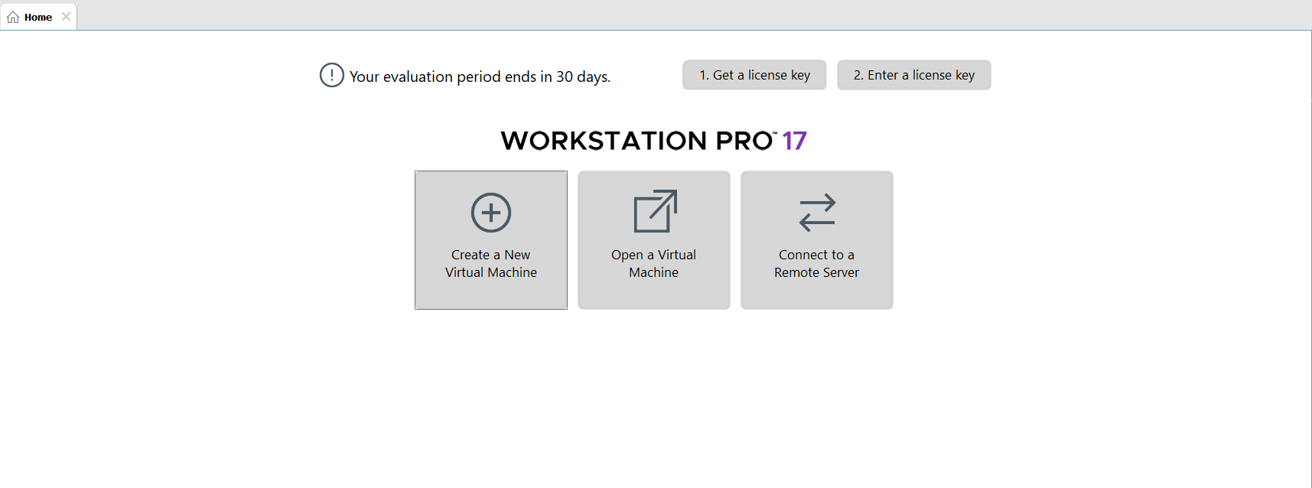

STEP 2: Create Virtual Machine
Click Create a New Virtual Machine
Select Typical (recommended) → Next
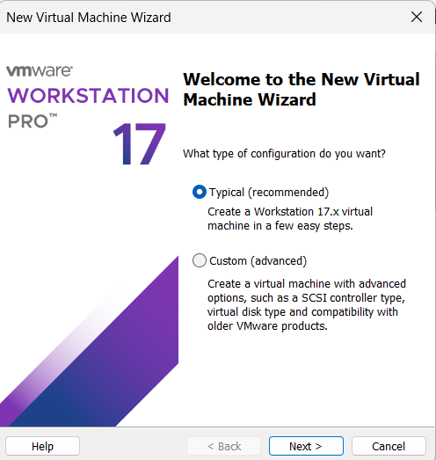

STEP 3: Select OS Installer
Choose Installer disc image file (ISO)
Browse and select Ubuntu ISO

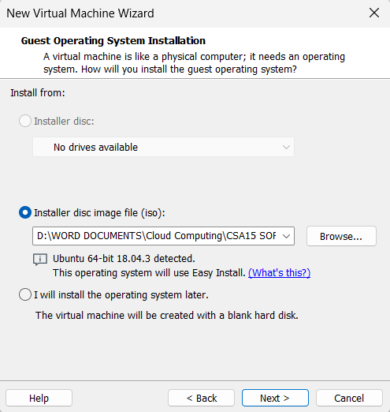

STEP 4: Name VM & Location
VM Name: Virtual Machine Ex-16
Choose location → Next
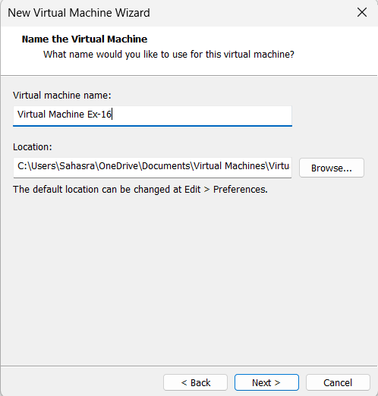

STEP 5: Finish Installation
Click Finish
Ubuntu starts installing automatically
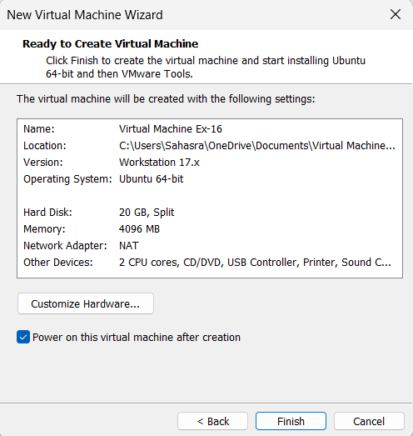

STEP 7: Save & Start VM
Click OK
Power ON the VM
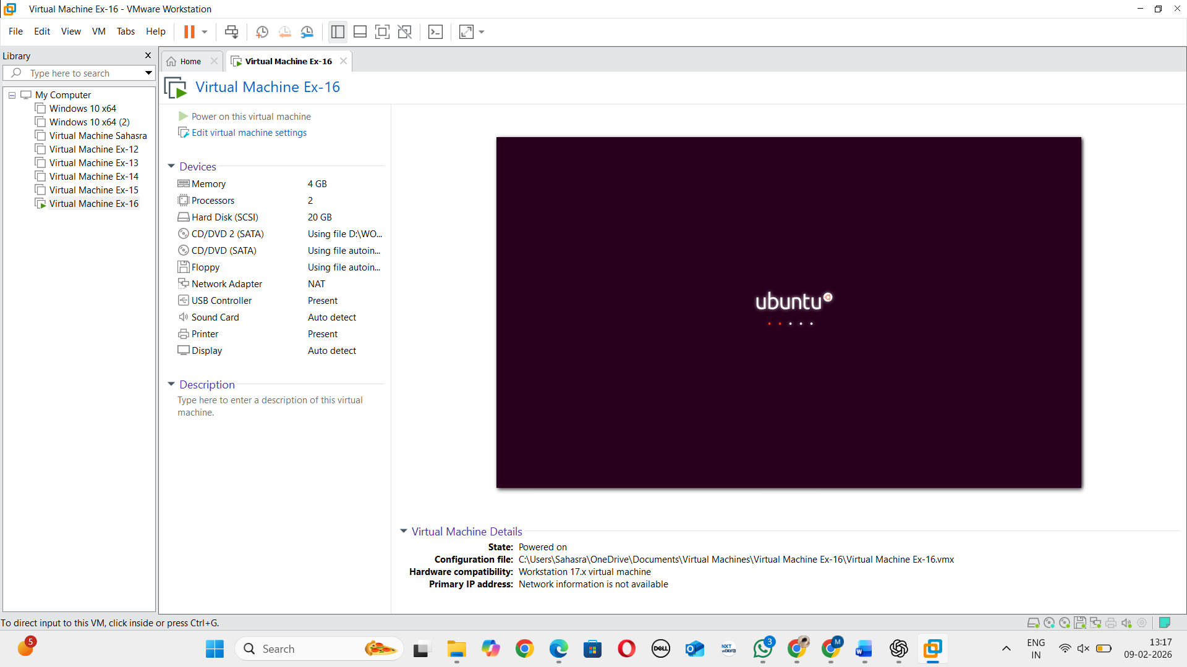

STEP 8: Power OFF VM
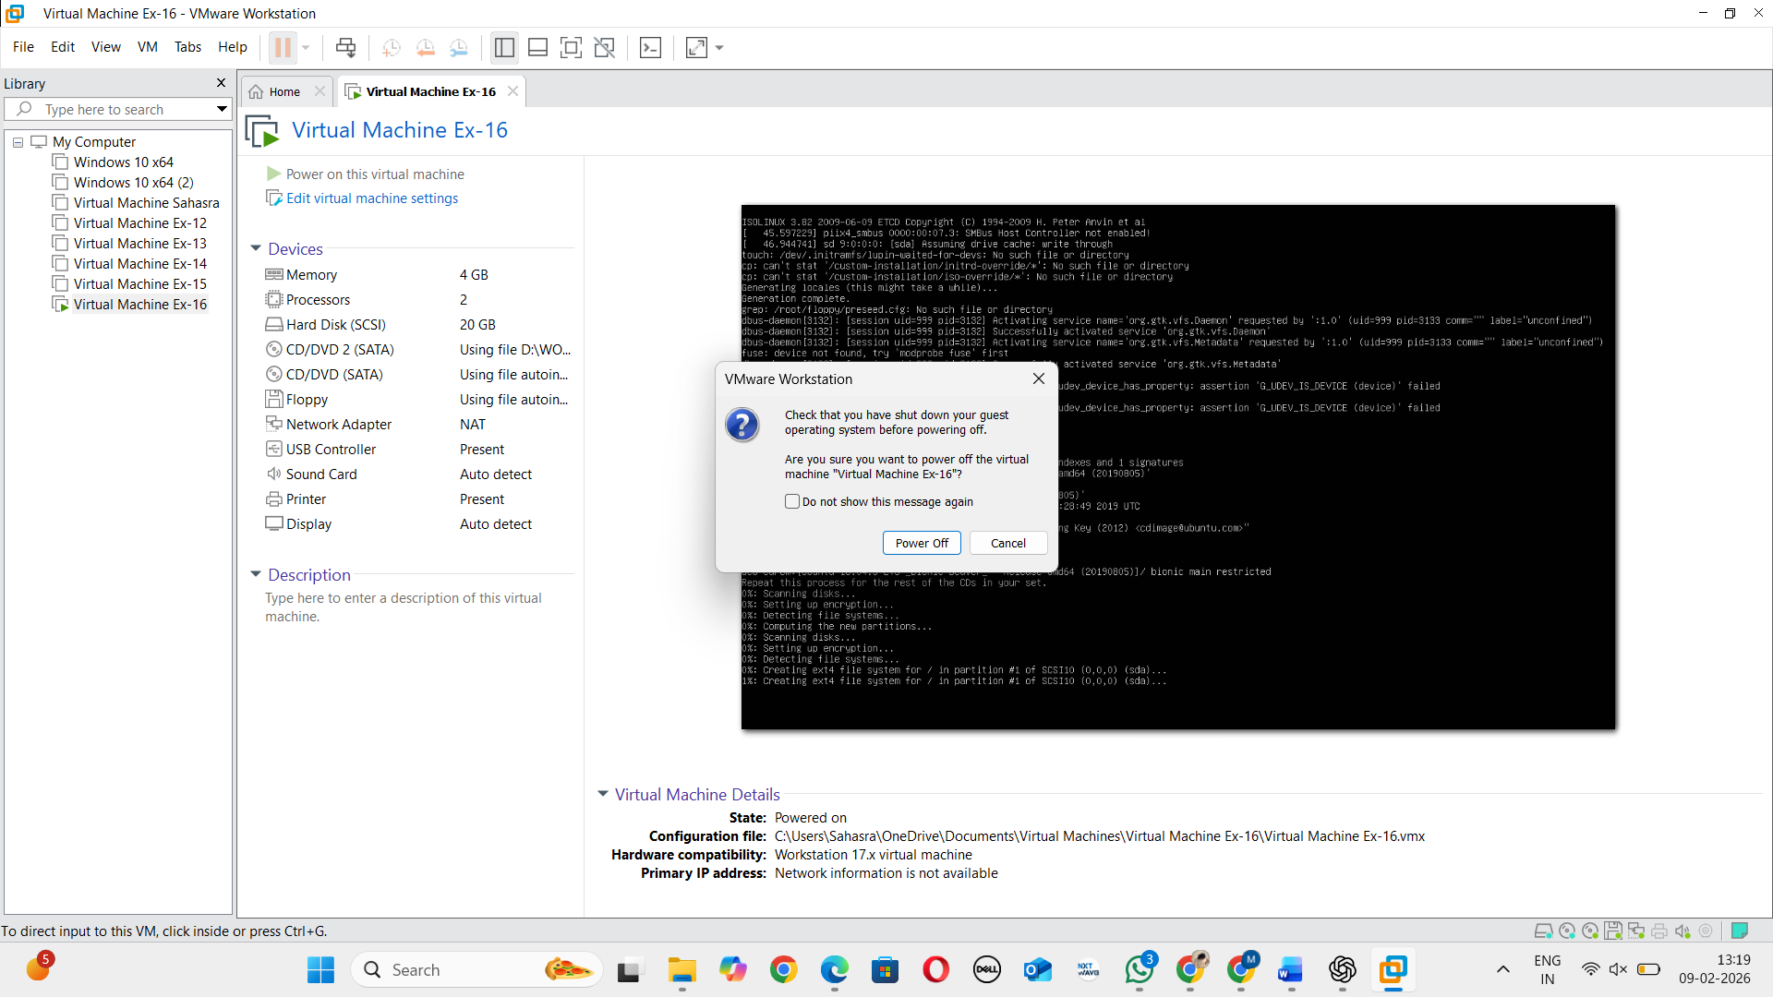

STEP 9: Start Clone Wizard
Right-click VM → Manage → Clone
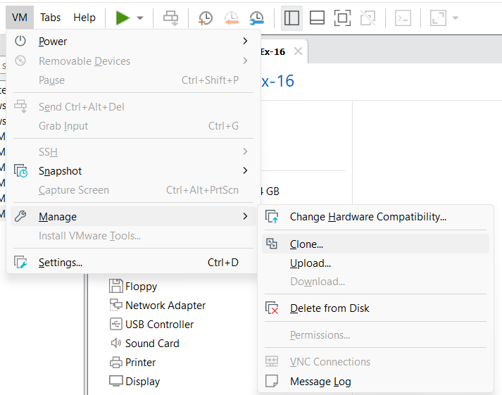
STEP 10: Choose Clone Type
Select Full Clone

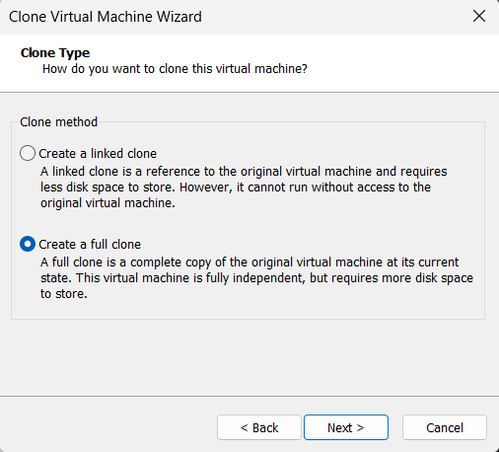
STEP 11: Name Cloned VM
Name: Clone of Virtual Machine Ex-16

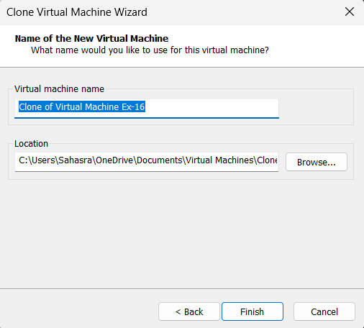

STEP 12: Finish & Run Clone
Click Finish
Power ON cloned VM

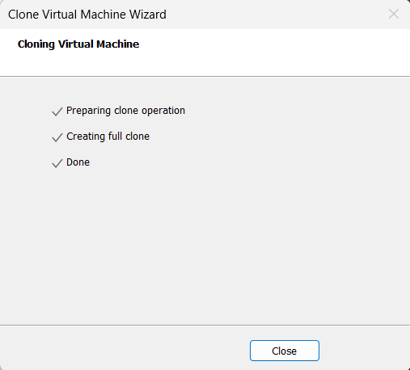

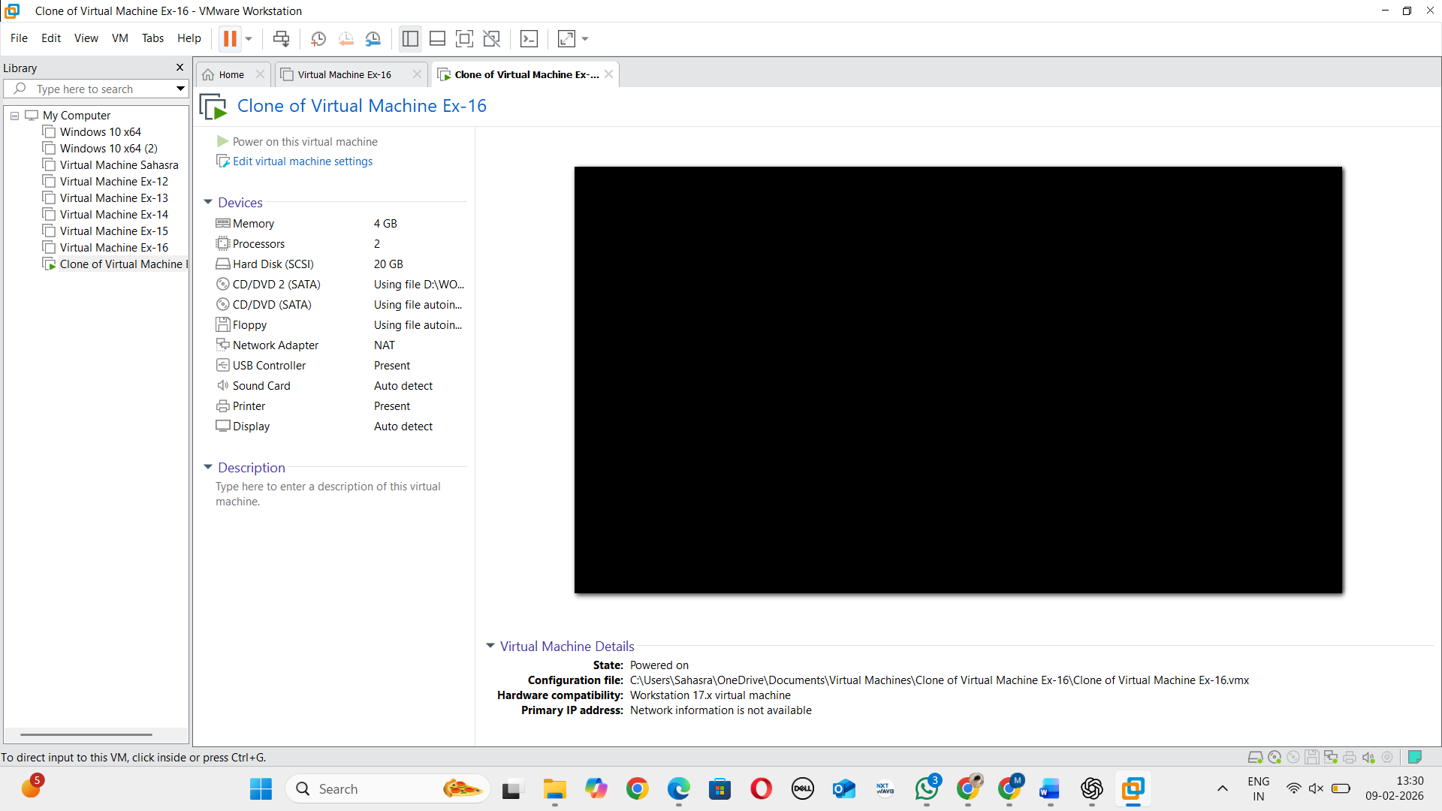

RESULT: VM cloning is successfully completed and tested.

